Notes on structure of Standard Panel Cell, circa 2019.

Main Task Program Schedule: Periodic at 10.0 ms, Priority 10, Watchdog at 500 ms
Festo Equipment refer to: Commissioning of E2M_EthernetIP.pdf
1. MD01_ManualWorkCell
MainRoutine
DM00_Mapping
EP00_MachineState
EP01_Initialize
EP02_Run
EP03_Terminate
EP04_ClearFaults
EP05_Manual

2. MD02_Elevator
MainRoutine
DM00_Mapping
EP00_MachineState
EP01_Initialize
EP02_Run
EP03_Terminate
EP04_ClearFaults
EP05_Manual

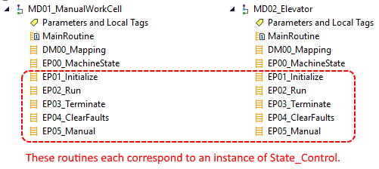

MD01_ManualWorkCell - DM00_Mapping

StartRequest
In EP00_MachineState: Not Initialized, Not Stopped, Not Faulted.
Stopped: ModuleState.Stopped is only asserted in one place, EP03_Terminate. It is asserted when Terminate.CMD is asserted.

Terminate.CMD is asserted in EP00_MachineState on rung 2 when ModuleState StopReq OR StopButton OR SafetyRelay1.

ManualWorkCell
ManualWorkCell is an instance of the UDT Module_Control in the Controller Tags group (global).

Manual
Manual is an instance of the UDT StateControl.
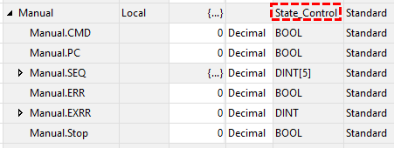

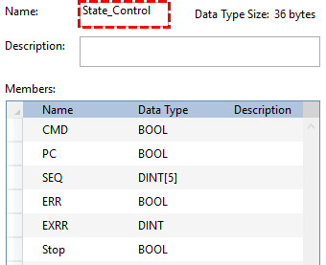

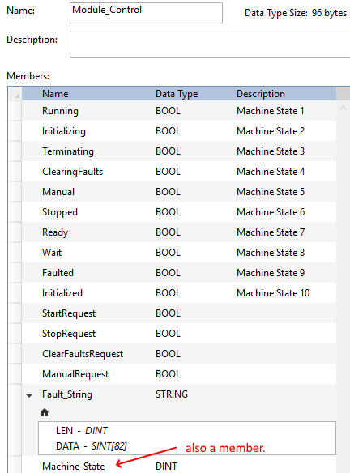
ModuleState

ModuleState is an instance of the UDT Module_Control.
ModuleState.Running active when cell is initialized, not stopped, and not faulted.
Most state transitions occur in EP00_MachineState.

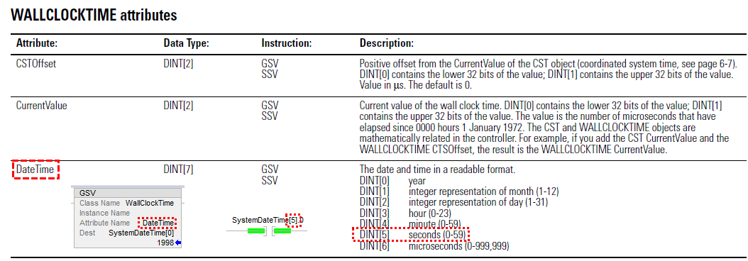

It appears that the purpose of the SystemDateTime[5].0 is to allow the start button lamp to flash off for one second (each minute?) when there are no faults and the machine is not running.

State Control

Same instances occur in both ManualWorkCell and Elevator

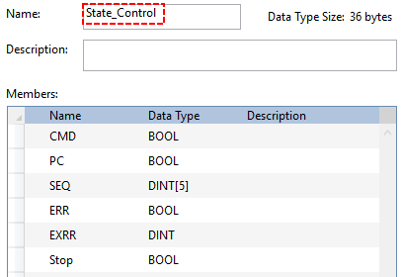

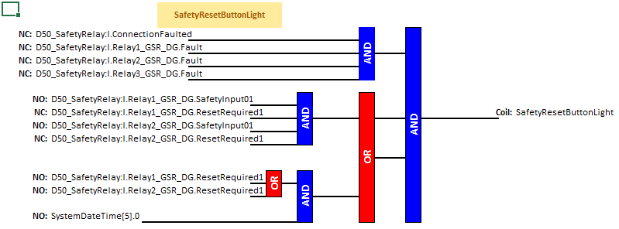
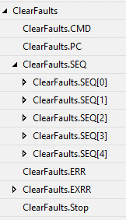 | 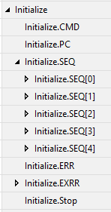 | 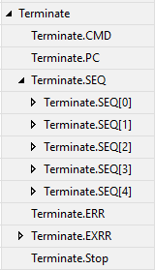
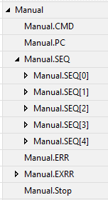 | 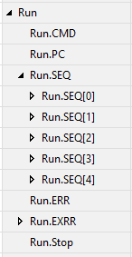

Initialize.CMD: energize and latch start pb.
When Initialize.CMD is not set Initialize.SEQ[0] is set to 0.
When Initialize.CMD is set and Initialize.SEQ[0] = 0 Initialize.SEQ[0] is set to 20.

Initialize.SEQ[0]: is set to 0 on the first scan.
It is held at 0 whenever Initialize.CMD is not set.
The first scan that Initialize.CMD is trueand Initialize.SEQ[0] = 0 Initialize.SEQ[0] is set to 20.
When Initialize.SEQ[0] = 20 and the palm switch is closed Initialize.SEQ[0] is set to 30.
When Initialize.SEQ[0] = 30 ModuleState.Initialized is set.
The purpose of Initialize.SEQ[0] = 30 seems tp be to set ModuleState.Initialized = True.
ModuleState.Initialized latches itself until ModuleState.Stopped = True.

